PROJECT NARRATIVES City of Helena Railroad Urban Renewal District TAX INCREMENT FINANCING APPLICATION FORM Community Development Department Phone (406) 447-8490 Fax (406) 447-8460 citycommunitydevelopment@helenamt.gov PROJECT NARRATIVES SECTION

1. Description of Project.
1316 Bozeman St. is an historic building, built in the 1880s as a warehouse and retail store for groceries and hardware. It has since been occupied by several owners, who used the venue mainly as grocery storage for Helena. For the last 80 years it has been occupied by a family-owned business: Capital Transfer and Storage, a residential and commercial moving, packing and storage business also offering to the community warehousing and shipping services.
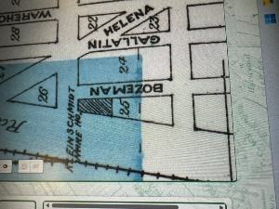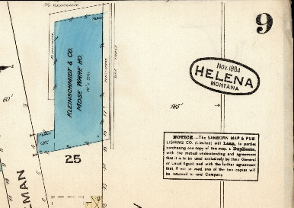
Map 1880 Map 1884
Its new lessee and future owner, Stephen Banker, of Joshua Tree Cabinetry, owns a thriving business - currently in the Valley, but moving to 1316 Bozeman St., the heart of Helena. Plans to renovate the building: restoring the exterior to its historical facade while renovating its structural integrity and strength so that it can be enjoyed by the district for generations to come. JTC is a light industry, exactly what the area is zoned for. Mr. Banker puts his heart and soul into his work, into his employees and has given back to the community throughout the years. His attention to detail and his creativity will help bring the building back to its historical look and feel.

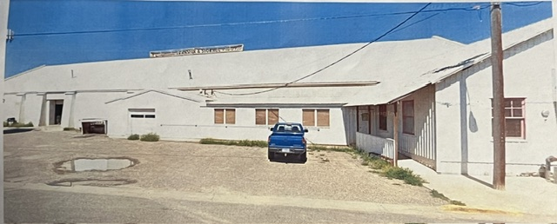
1316 Bozeman before Mr. Banker began work on the building.
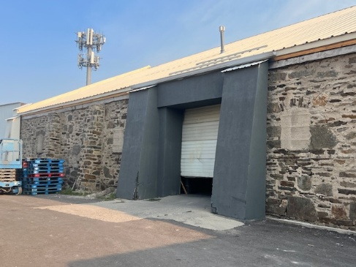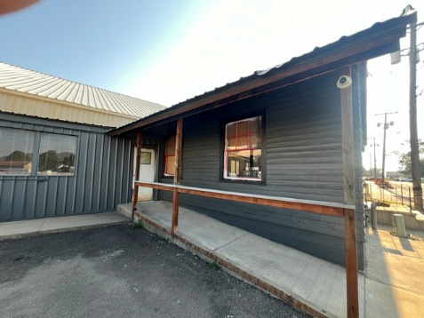
**On the left, some of the stonework Mr. Banker discovered behind the siding. On the right, he restored the clapboard on the office. And he has painted the front of the building… samples of his renovation work.

Joshua Tree Cabinetry is a high quality business. They have contracted with local companies to do much of the work on the building. These will have the opportunity to enjoy the businesses, coffee shops, etc. available in the area. There will be an historical information display inside the building, showing the various owners of the building as well as the story of Capital Transfer and Storage, for anyone to enjoy. Two elements to be added are a sidewalk water spicket, and air (for tires) for cyclists coming through the district.
The goal is adaptive reuse and structural strength: to renovate and restore the integrity of the building and its original, historical look and feel. Many aspects of the building need replacement and/or restoration: overhead doors, broken stonework and deteriorated pointing, all doors, all windows and panes (some of which are cemented over), corroded window wells, barn doors in the back of the building (some of which are cemented over). Gutters all around the building will need to be built for the preservation of the stone walls and mortar: to prevent freeze/thaw damage, mortar erosion and efflorescence (which indicates that moisture is penetrating or moving through the masonry) as well as preserving the foundation of the building. Per Karson Klass, the contracted mason, “repointing will take place on the bottom portion of the building due to lack of gutters and water splash deteriorating the mortar.” Repointing also needs to be completed on all areas of the stonewall (per a sampling of photos below). JTC is hoping to replace the sign on top of the warehouse, though it has been a challenge to find a company to commit to it. Karson Klass plans to match chemical / materials balance of the original mortar.
JTC has already restored the clapboard siding of the office exterior (see photos above). Windows will be replaced with energy-efficient windows.

The handicapped ramp needs to be extended to meet code. The restoration will both enhance the historic appeal of the building as well as its structural sturdiness and usefulness both in the front and the back of the building.
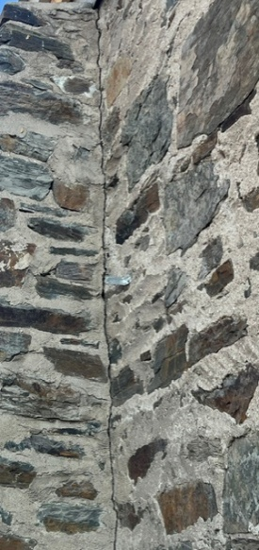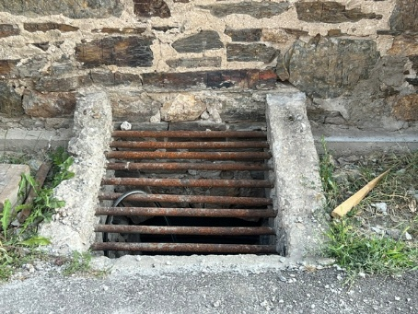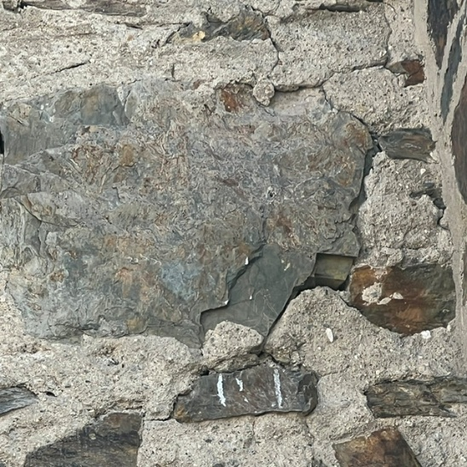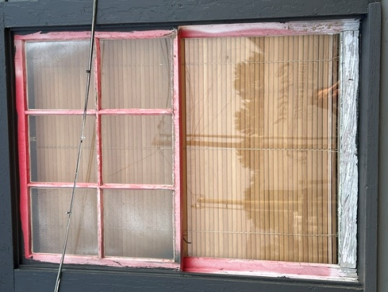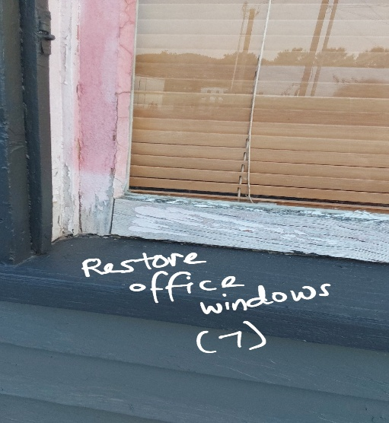

Deterioration in pointing and window wells on front. Windows need replacement.

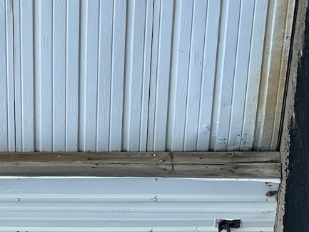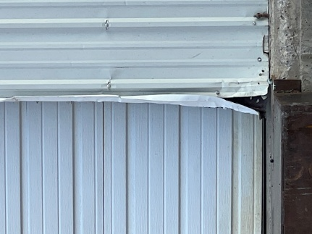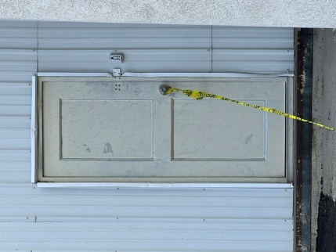
Front overhead doors to be replaced. One of 2 man doors to be replaced.
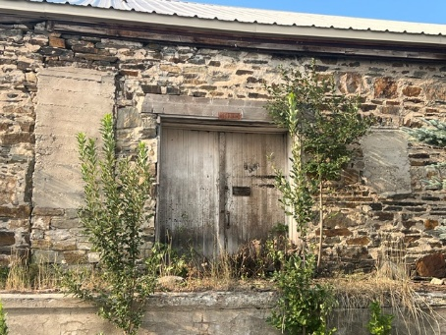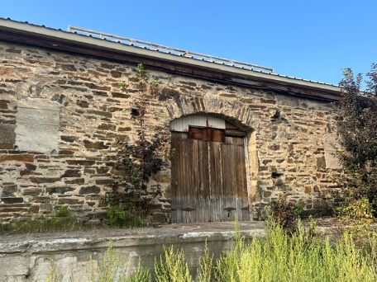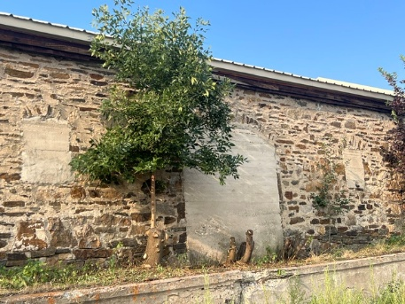
Barn doors, concrete-covered windows and doors to be rebuilt along the back of the building.

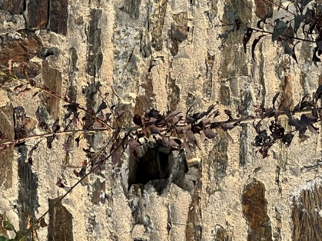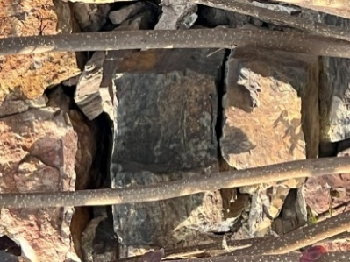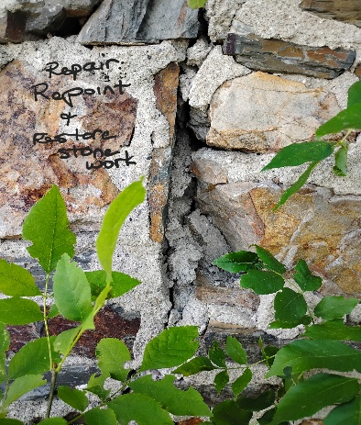
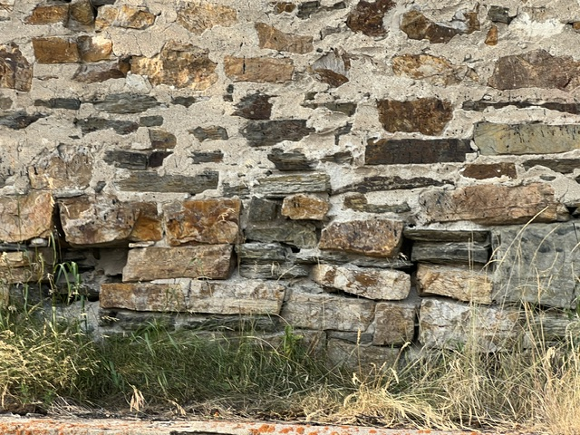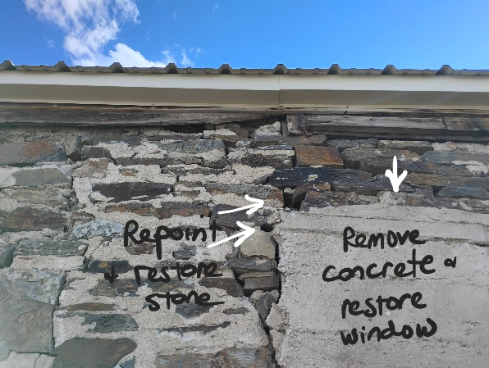
Just a few samples of holes, cracks and deterioration along stonewall.
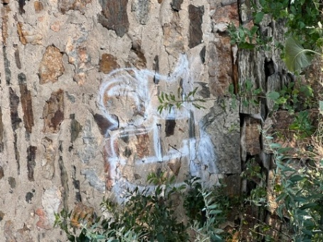
Graffiti to be removed (2 instances)

Compliance with the Railroad URD Plan:
Per above, Joshua Tree Cabinetry complies with many of the RURD goals.

Emphasize the District’s Historic Importance: Not only is JTC restoring the original look of 1316 Bozeman St., but it is also restoring its structural integrity so that it will retain its historic look and feel for years to come. Pam Attardo and the Historical Society have provided interesting information, maps and photos which we will seek authorization to use as a historical display showing maps, photos and information about the history of the building and companies that have owned it throughout the years. With John Horne’s blessing, JTC will brighten and restore the mural painted on the smaller building on the property.
We have already reached out to BNSF and have begun correspondence with the gentleman in charge of 1316 Bozeman St. property.
Increase Property Utilization and Function: Joshua Tree Cabinetry, a thriving business, will bring new business and vitality into the venue. (JTC is currently located in Helena valley.)
Expand and Diversify the District’s Economy: Joshua Tree Cabinetry, a light industry, will fit perfectly into the zoning of the area.
JTC is definitely interested in providing opportunities for high school and Helena College students to be trained in carpentry and woodworking. JTC has worked with a school in the district and has already hired a high school student who has had a secure position with the company for 4+ years. JTC has also contributed to the community in other ways. Address Public Infrastructure Needs: Two elements to be included in the plans are a sidewalk water spicket, air (for tires) for cyclists coming through the district, as well as a display of the historical timeline of use for the building. The mural of the RURD, painted on a smaller building on the property, is also going to be restored.
Provide for Public and Environmental Health: The handicapped ramp needs to be extended to meet ADA code. Other elements to be included in the plans are a sidewalk water spicket, and air (for tires) for cyclists coming through the district.
b. Local Zoning and Other Requirements: Joshua Tree Cabinetry complies with the City’s Zoning Requirements, being light industry/manufacturing. Mr. Banker plans to remove or trim the foliage around the building for utility and aesthetics. He has hired a contractor to repoint and repair the stonework, restoring its integrity and historical appeal. He has contracted to replace the overhead doors, windows, man doors. He will be restoring the window wells, remove concrete from the windows (back and front) and doors in the back, and rebuild barn doors at the back of the building. For the preservation of the stone work and mortar he will contract a gutter to surround the roof. To meet ADA requirements, he will also rebuild the handicapped ramp, door and entrance. Mosaic Architecture is soon to get back to us regarding engineering standards.
c. Demolition/Deconstruction: There will be no removal of structures, nor demolition of properties.
d. Dislocation: No tenants are to be dislocated as a result of the project, since there are no tenants living on the premises.
2. Logistical Considerations.
a. Project Feasibility: Mr. Banker has already begun work, investing some of his own funds and capability, reflecting his interest and intentions to follow through with the project. (**see photos above) He has obtained a line of credit from a home equity loan of up to $250,000.
b. Applicant’s Ability to Perform: As seen by what Mr. Banker has already accomplished in beginning renovations of the building, he is talented, creative and accustomed to working with contractors.
c. Timely Completion: The project is anticipated to be completed by the end of 2027, though much of the work has begun or will begin in 2026.
d. Payment of Taxes: All taxes are up to date. (See copy of 2025 property taxes.)
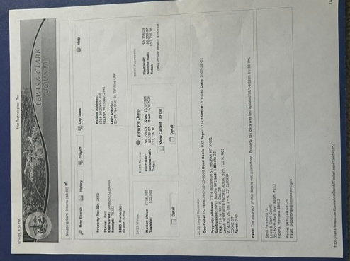

3. Economic & Community Development Potential: The overall restoration will enhance both the historic appeal of the building as well as its structural sturdiness and usefulness both in the front and the back of the building.
a. Tax generation: The adaptive reuse of the building involves bringing in a thriving business, Joshua Tree Cabinetry, its customers and employees to the RURD. Along with the contractors and workers on the project, it will also bring patronage to businesses in the community. Renovations to the building’s exterior and mural will renew the appeal of the building, benefiting the district.
b. Relationship of Public and Private Investment: Mr. Banker has already expended some of his own capital, reflected in the photos above. He will continue to invest in the renovation / restoration project as needed. It is a prudent investment of public funds within the urban renewal district as it is reviving the original, historic façade of the building and adding appeal to the District. Also, the work being done will strengthen the building structurally for years to come.
c. Job Creation: The renovation of the building means that JTC is hiring contractors from Helena, and their workers and may very well be hiring more employees due to the increased space and work capacity of the building. This will also increase patronage to the businesses in the area.
d. Investment Spin-off: See photos above, which show that work already begun reveals attractive, historic stonewall and clapboard. A mural illustrating the District’s history is painted on a smaller building on the property, and will be renewed. The continued renovation of the building will hopefully inspire other building owners in the District to renovate their properties as well, to enhance the historical feel and attractiveness of the area.
e. Cost-Benefit Analysis of the Investment/Expenditure: This project will bring increased tax revenue to the community, preserve and reveal this historic building for the community to enjoy and possibly to inspire others in the area to renovate their buildings to reflect the historicity of the District. It will bring a new business into the area, and it will increase the activity in the surrounding area.
f. Health and Safety Concerns: The project’s impact on the area will be minimal as far as safety concerns, pollution, traffic congestion and pedestrian access. There may be noise and dust for a few days while removing mortar, and concrete from windows and doors.
g. Historic Preservation: The goal of the project being proposed is to rediscover the historic façade of this building. JTC will need to restore windows, doors and the entire exterior – not only to reveal its historicity, but also to rebuild and restore its structural integrity. The above photos reveal a stone wall, clapboard siding and other elements which had been hidden from view until recently. Joshua Tree Cabinetry plans to (contract out to) repoint and restore the stone wall to its original appeal and durability, remove cement from in front of some of the windows and doors and replace the windows and doors. Thus, JTC is bringing the building to life and closer to its historical appeal for generations to come. JTC will be bringing its business to the building, so bringing a thriving business into the area.
h. Density, Infill, and Adaptive Reuse: Mr. Banker is adapting 1316 Bozeman St. from a warehouse to a viable cabinetry business while restoring its historic, aesthetic appeal and creating value to the surrounding Railroad District. It will reveal and retain its historical facade, as well as strengthen the integrity of the building to prolong its structural integrity for years to come. Included in the restoration will be energy-efficient windows. There will be no density nor infill in this project.
i. Cost of Public Services: JTC is planning to add a water spicket and air (for tires) for public use, as well as restore the mural on the smaller building on the property. Also, the handicapped ramp leading to the office will be extended for ease of use, and the entrance will be enhanced for ease of use.
j. Housing Component: We have no plans for housing.
k. Conformance with Requirements for TIF Fund Expenditures, per 7-15-4288, MCA:
We are in compliance with 7-15-4288, section….. (I am still studying this )

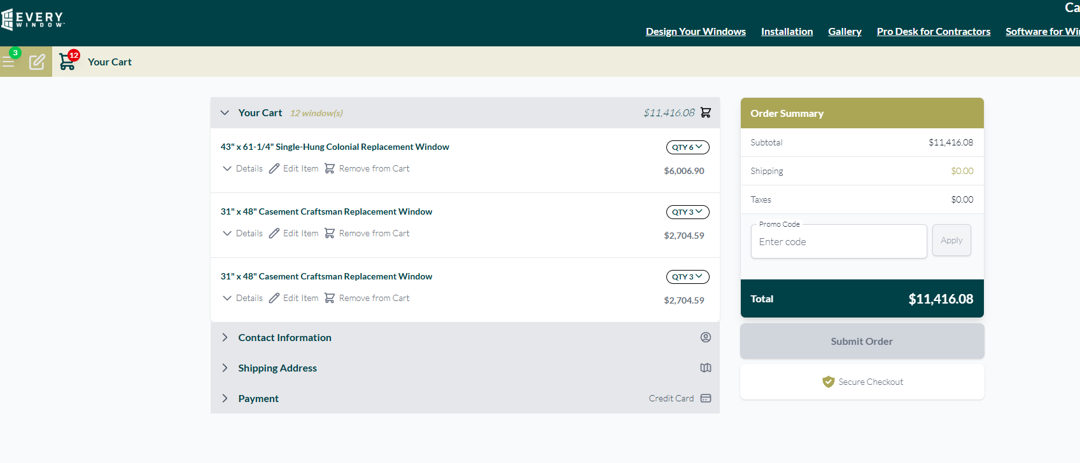

Capital Glass Quotes:

--drawings


4064428940
sales@ohdhelena.com
Estimate #710
Estimate for Joshua Tree Cabinetry
For: Joshua Tree Cabinetry, Joshua Tree Cabinetry,
1316 Bozeman Ave, Helena, MT 59601
Created on: Sun Jul 19, 2026
Expires on: Tue Sep 08, 2026
Option #1
$19,220.00
Approved
Approved on Jul 21, 2026.
Services
Amount

Commercial Services * - COMMERCIAL Install Labor *
Install New Commercial Door and/or Operator Install 3 receiving bay doors
$1,800.00

Commercial Services * - COMMERCIAL Install Labor *
Install New Commercial Door and/or Operator Install front 2 doors and raynor replacements
$1,600.00

Commercial Services * - COMMERCIAL Install Labor *
Install New Commercial Door and/or Operator Install Rolling Sheet Door, Service and get the 2 middle doors moving properly
$600.00

Services subtotal
$4,000.00

Materials
Qty
Unit price
Amount

Thermacore® Commercial Doors - 591 Heavy Duty
Panel thickness- 1 5/8'' R-value- 14.86 Exterior surface- ribbed Color options- white, gray, tan, industrial brown, black, trinar white, trinar, brown, trinar beige Wind load- designs available for usage in high wind conditions Warranty- 1 year limited warranty FRONT RIGHT DOOR DOOR: 591, 8' 2" x 7' 1", Ribbed Panel, Black, 4 Sect, SES, Std Btm Seal, Dual Flap WEATHERSTRIP: Sides Only, Side: Saverstrip, Black, Black LITES: Third Section Only, 24" x 7" Clear DSB Insulated, , Full Row STRUTS: Custom, S1: 2" STRUT x 2, S2: 2" STRUT x 1, S3: 2" STRUT x 1, S4: 2" STRUT x 1 LOCK: ISL, 2 TRK/HDW: Metal Step Plate/Lift Handle, Gray, 2", LHR: 10, Angle In, Steel, Leaf Bumper, 0.055 V.Trk, 0.055 H.Trk, 89.75 FTSC SPRING: Torsion, Qty: 1, Front, 10K, Tubular, 2" x 0.244 x 26.25, 7.26 Turns, D400-96, 1/8" x 95", Bal Wt: 167.43 OPERATION: Push Up
1.00
$1,925.00
$1,925.00

Thermacore® Commercial Doors - 591 Heavy Duty
Panel thickness- 1 5/8'' R-value- 14.86 Exterior surface- ribbed Color options- white, gray, tan, industrial brown, black, trinar white, trinar, brown, trinar beige Wind load- designs available for usage in high wind conditions Warranty- 1 year limited warranty FRONT LEFT DOOR DOOR: 591, 9' 2" x 10' 1", Ribbed Panel, Black, 5 Sect, SES, Std Btm Seal, Dual Flap WEATHERSTRIP: Sides Only, Side: Saverstrip, Black, Black LITES: Third Section Only, 24" x 7" Clear DSB Insulated, , Full Row STRUTS: Custom, S1: 2" STRUT x 2, S2: 2" STRUT x 1, S3: 2" STRUT x 1, S4: NONE, S5: 2" STRUT x 1 LOCK: ISL, 2 TRK/HDW: Metal Step Plate/Lift Handle, Gray, 2", HL, HL Amt: 24, Angle In, Steel, Leaf Bumper, 0.055 V.Trk, 0.055 H.Trk, 1" X 1.750" X .099" H.Ang, 149.625 FTSC, 32.468 Min HR Req SPRING: Torsion, Qty: 2, Front, 10K, Tubular, 2" x 0.234 x 40.75, 11.94 Turns, D400-54, 1/8" x 188", Bal Wt: 237.73 OPERATION: Push Up
1.00
$2,603.00
$2,603.00

Thermacore® Commercial Doors - 591 Heavy Duty
Panel thickness- 1 5/8'' R-value- 14.86 Exterior surface- ribbed Color options- white, gray, tan, industrial brown, black, trinar white, trinar, brown, trinar beige Wind load- designs available for usage in high wind conditions Warranty- 1 year limited warranty LEFT SIDE RECEIVING DOOR DOOR: 591, 8' 2" x 10' 1", Ribbed Panel, Black, 5 Sect, SES, Std Btm Seal, Dual Flap WEATHERSTRIP: Sides Only, Side: Saverstrip, Black, Black LITES: Third Section Only, 24" x 7" Clear DSB Insulated, , Full Row STRUTS: Custom, S1: 2" STRUT x 2, S2: 2" STRUT x 1, S3: 2" STRUT x 1, S4: NONE, S5: 2" STRUT x 1 LOCK: ISL, 2 TRK/HDW: Metal Step Plate/Lift Handle, Gray, 2", 15"R, Angle In, Steel, Leaf Bumper, 0.055 V.Trk, 0.055 H.Trk, 1" X 1.750" X .099" H.Ang, 132.125 FTSC SPRING: Torsion, Qty: 2, Front, 10K, Tubular, 2" x 0.219 x 31.25, 10.7 Turns, D400-123, 1/8" x 140", Bal Wt: 217.32 OPERATION: Push Up
1.00
$2,262.00
$2,262.00

Thermacore® Commercial Doors - 591 Heavy Duty
Panel thickness- 1 5/8'' R-value- 14.86 Exterior surface- ribbed Color options- white, gray, tan, industrial brown, black, trinar white, trinar, brown, trinar beige Wind load- designs available for usage in high wind conditions Warranty- 1 year limited warranty RIGHT RECEIVING DOOR DOOR: 591, 12' 2" x 10' 1", Ribbed Panel, Black, 5 Sect, SES, Std Btm Seal, Dual Flap WEATHERSTRIP: Sides Only, Side: Saverstrip, Black, Black LITES: Third Section Only, 24" x 7" Clear DSB Insulated, , Full Row STRUTS: Custom, S1: 2" STRUT x 2, S2: 2" STRUT x 1, S3: 2" STRUT x 1, S4: 2" STRUT x 1, S5: 2" STRUT x 1 LOCK: ISL, 2 TRK/HDW: Metal Step Plate/Lift Handle, Gray, 2", 15"R, RoofPitch: 1, Angle In, Steel, Pusher Springs Bumper, 0.055 V.Trk, 0.055 H.Trk, 1" X 1.750" X .099" H.Ang, 132.125 FTSC SPRING: Torsion, Qty: 2, Front, 10K, 1" Solid, Two-Piece Split Solid Shaft w/Coupler, 2" x 0.25 x 44, 11.6 Turns, D400-123, 1/8" x 140", Bal Wt: 313.4 OPERATION: JackShaft, Side Mount OPERATOR: RMZ - Medium Duty, D400-123, 1/2 HP, 115V 1Phase 60Hz, Hoist, Left, PhotoEyes-Protected (Monitored), Direct Couple, 1:1 Direct Couple Kit, Brake ACCESSORIES: CodeDodger, 315MHz, 1-BTN: 1, Hand Chain,14'
1.00
$4,543.00
$4,543.00

Thermacore® Commercial Doors - 591 Heavy Duty
Panel thickness- 1 5/8'' R-value- 14.86 Exterior surface- ribbed Color options- white, gray, tan, industrial brown, black, trinar white, trinar, brown, trinar beige Wind load- designs available for usage in high wind conditions Warranty- 1 year limited warranty REAR RECEIVING DOOR DOOR: 591, 8' 2" x 8' 1", Ribbed Panel, White, 4 Sect, SES, Std Btm Seal, Dual Flap WEATHERSTRIP: Sides Only, Side: Saverstrip, Black, Black STRUTS: Custom, S1: NONE, S2: 2" STRUT x 1, S3: NONE, S4: 2" STRUT x 1 LOCK: ISL, 1 TRK/HDW: Metal Step Plate/Lift Handle, Gray, 2", 15"R, Angle In, Steel, Leaf Bumper, 0.055 V.Trk, 0.055 H.Trk, 108.125 FTSC SPRING: Torsion, Qty: 1, Front, 10K, Tubular, 2" x 0.25 x 34.5, 8.9 Turns, D400-96, 1/8" x 116", Bal Wt: 156.13 OPERATION: Push Up
1.00
$1,597.00
$1,597.00

Raynor Replacement Panel
Raynor Thermaseal 8.02 x 24" x 3" Brown New Horizontal Track
1.00
$1,246.00
$1,246.00

Raynor Replacement Track
REP ITEM: Replacement Track, Track Bundle TRK/HDW: 2", 11 Gauge End / Standard Center Hinges, HL, BreakAway, HL Amt: 24, Angle Out, Wood, Pre-Assembled Track, Leaf Bumper, 0.055 V.Trk, 0.075 H.Trk, 32.625 Min HR Req
1.00
$804.00
$804.00

Raynor Replacement Spring
0.273"x2"x43" LH/RH Pair w/ Cones
1.00
$240.00
$240.00

Materials subtotal
$15,220.00

Subtotal
$19,220.00

Total
$19,220.00
Deposit (due 09/08)
$11,532.00
Documents (1)

rmz-jackshaft-operator---brochure.pdf
374 kb
Photos & videos (5)

Karson Klass Masonry
Joshua Tree Bozeman Ave Repointing:
This estimate is for the repair of faulty mortar joints out at 1316 Bozeman Ave. The majority of the repointing will take place on the bottom portion of the building due to lack of gutters and water splash deteriorating the mortar. On the front there are two sections, one 18’ and one 30’ by 2’ high where the mortar is deteriorated. All mortar joints will be removed to a structural point and a new mortar joint will be grouted/pressed/struck clean to finish. All of mortar repair is minor and will be spot check on the front. On the back of the building the entire bottom 3’ will be repointed, the building runs 172’. Just as the front all mortar will be removed to a structural
point and a new mortar joint will be grouted/pressed/struck clean. There are also 2 larger section one on the west side 42”x9’ and one on the west side 4’x5’ which the entire area will be repointed, there may be some stone removal and reset in these areas.
Total Estimate: $6300
Thanks,
Karson Klass
Karson Klass Masonry
Phone: (406)-459-6734
Email: karson.klass@gmail.com

